1. Feature triangles detection
For the triangles (v1, v2, v3) on the non-obtuse mesh
1). we can project each vertex v1 onto the original mesh, if the projected point located on a triangle with normal n1. Similarly we can get n2 and n3.
2). If dot(v1, v2) < 0.9, then edge (v1, v2) crosses a sharpe feature line
3). If a triangle has two edges crossing feature lines, it crosses the feature line shown in the left of the followed figure. If triangle has three three edges crossing feature lines, it crosses a corner point.
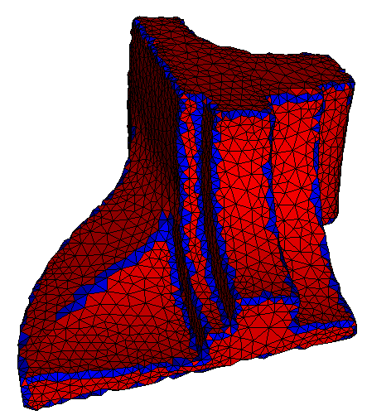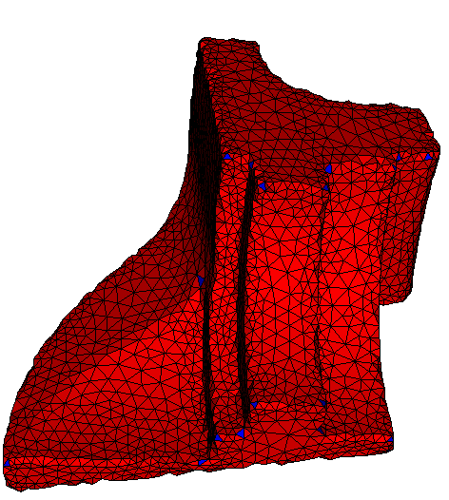
The triangles that cross sharp edges The triangles that cross corner points

2. Correspondences of the 1-to-4 subdivision
If (v1, v2) crosses a feature line, then the corresponed point of it’s midpoint is the projection on (v1 + v2) / 2 onto the intersected line of two planes p1 and p2. Plane p1 passes through point v1 with normal n1.
For other vertices, we just use point-to-sureface correspondences.
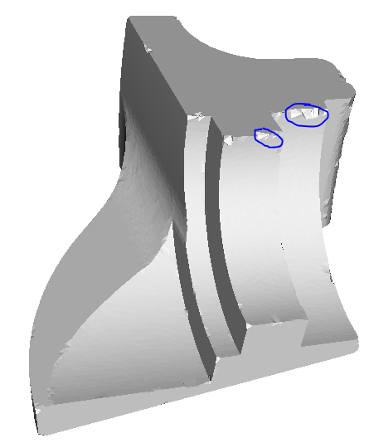
The correspondence result

3. Deform-to-fit

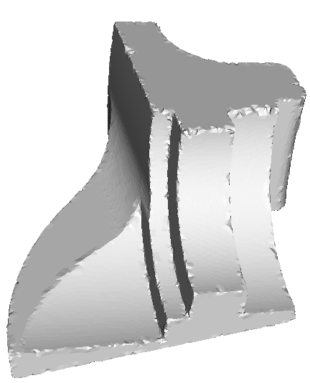
Correspondence Deform-to-fit result

In the sharp feature regions, the constraints are rigid and the vertices cannot move.

